**Hash**

**\\ Pre Code //**

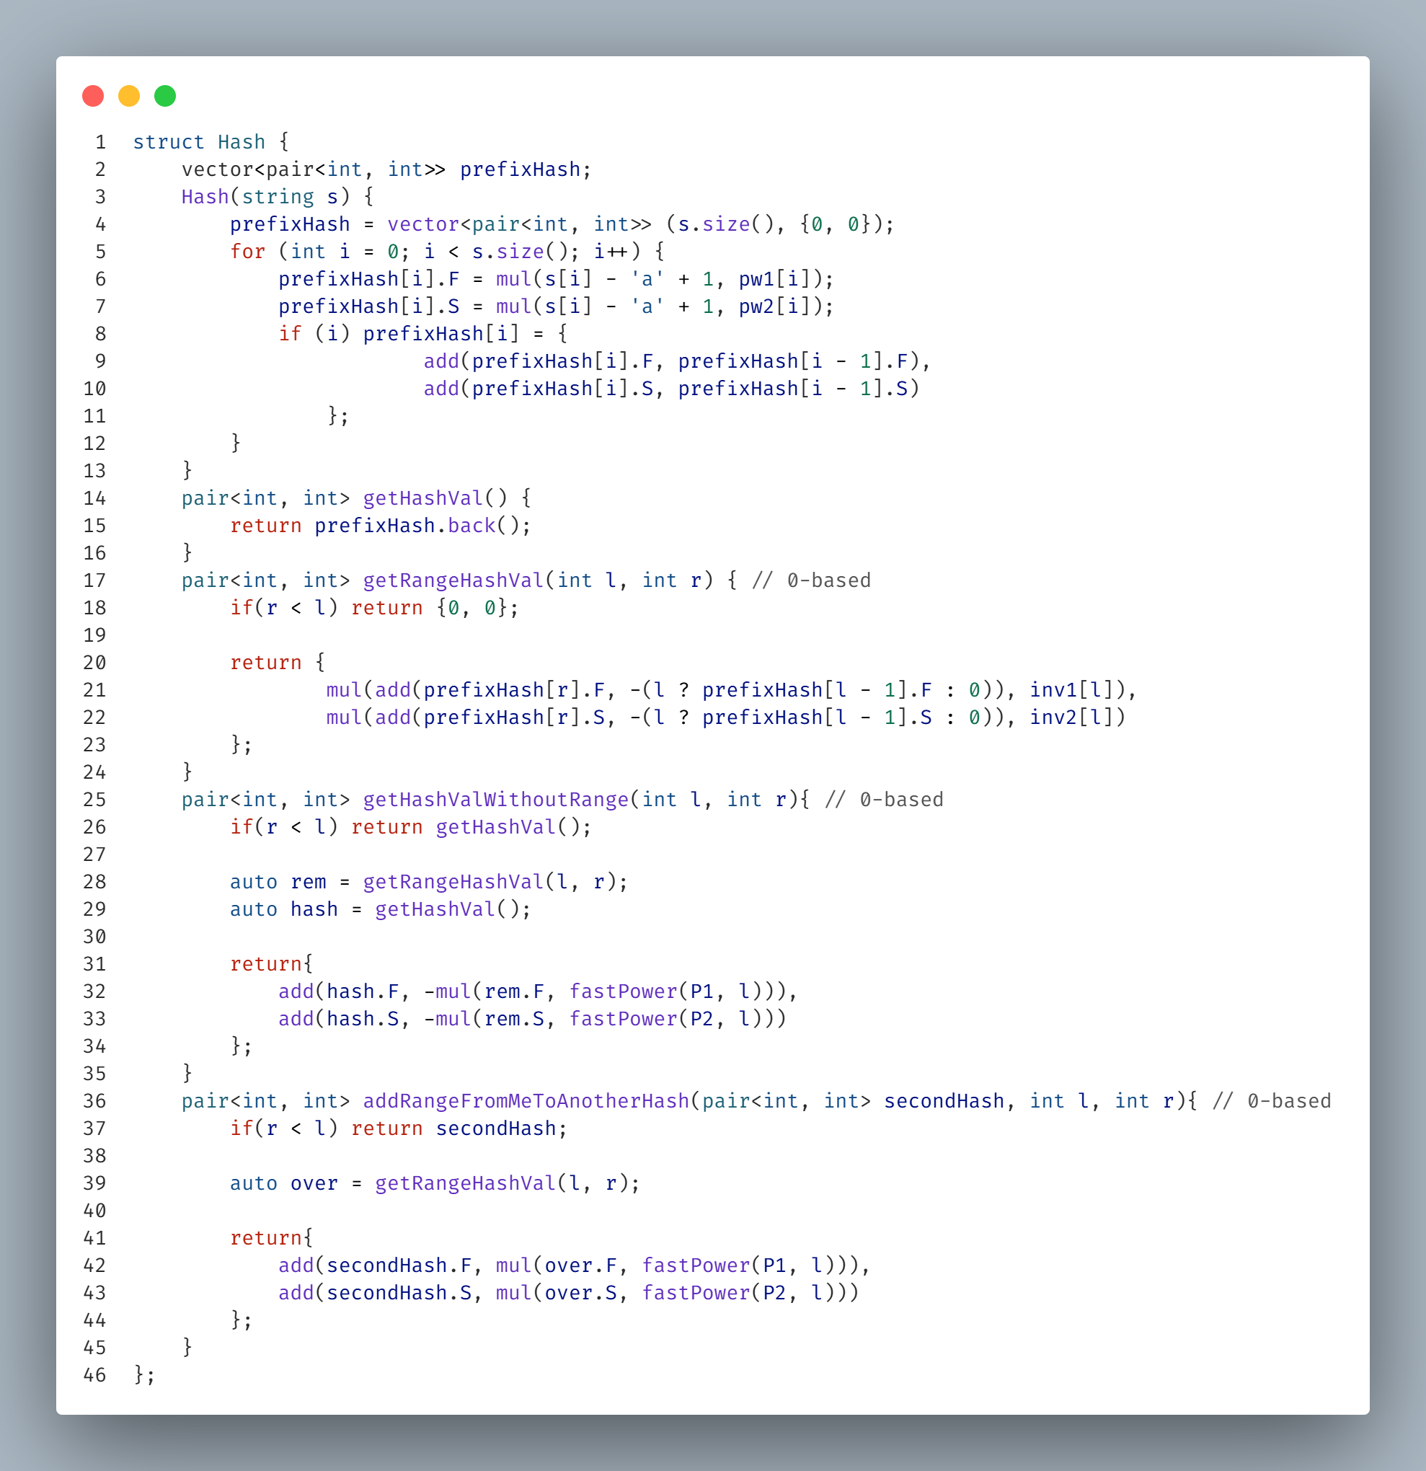**\\ Base Code //**

**Suffix Array**

**\\ Start //**

**\\ Base Code(private) //**

**\\ Base Code(public) //**

**\\ Accessors //**

**\\ Utility function //**

**Print(Suffixes, LCP, Order, Strings, C)**

**\\ Applications //**

**Count Distinct Substrings, Longest Common Substring**

Z Algorithm

Suffix Automaton

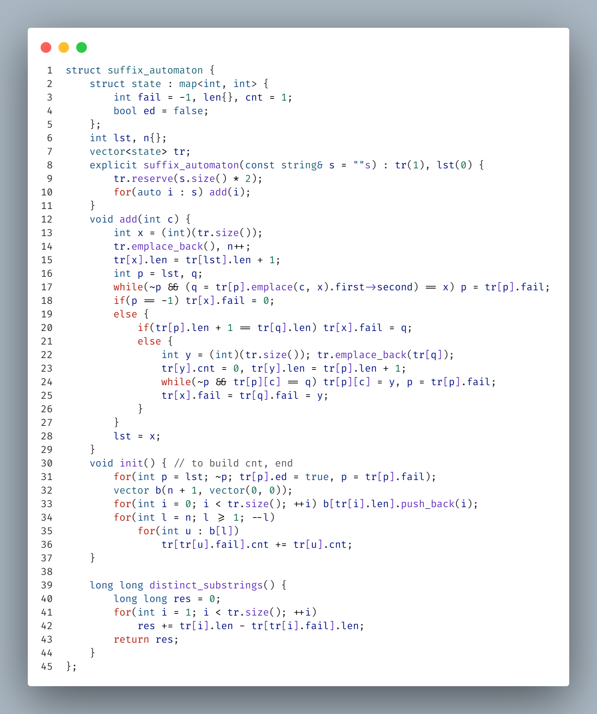**\\ Base code //**

**\\ Applications //**

Longest Common Substring

Longest Palindromic Substring

Find Occurrences

Lex Smallest Substring

Longest Repeated Substring

Largest Lex Substring

Manacher

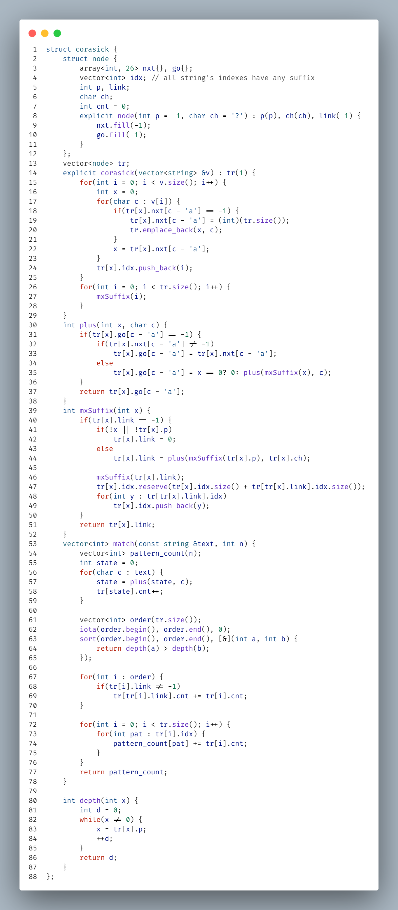**Aho Corasick**